**“NEXUS COMMUNICATION SERVICES’’**

**group members**

**Project Instructor**

**Miss Sana Sheeraz**

AHSAN JAMEEL

M ZAFEER ANSARI

ABU-HURRAIRA KHAN



HOME PAGE:

In home page we have sections.

1. In navbar we have 6 pages and all are interlink to each other.
2. In front we have our tag line and some brief intro of our web application.
3. In down more, we have our services section which contain tele-communication and broadband.
4. In the end of home page, we have our price plan and footer.
5. Footer contains our social links and header links.

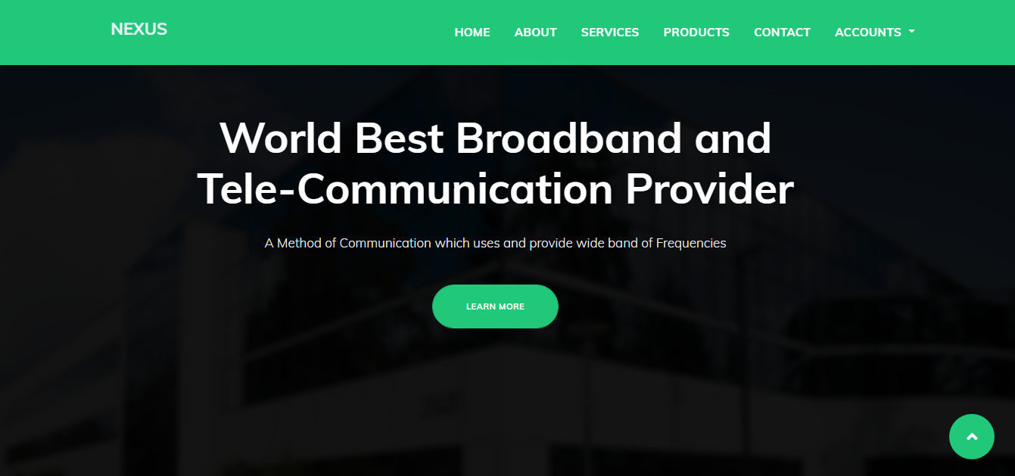

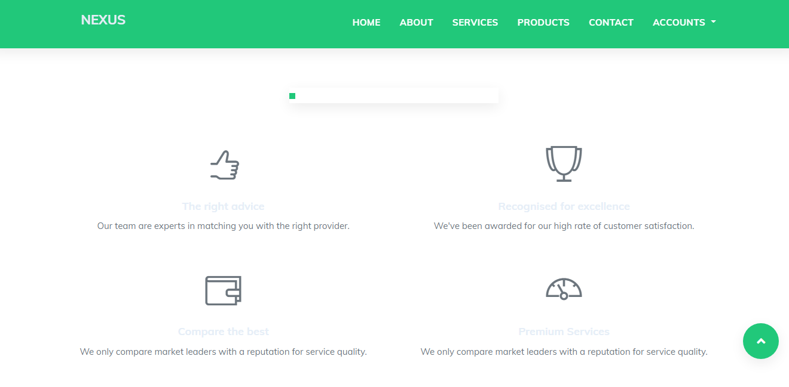

RTGRFGRF

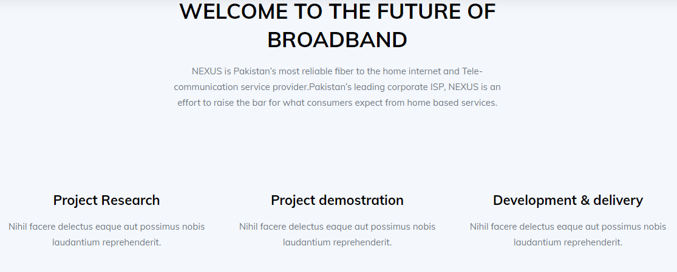

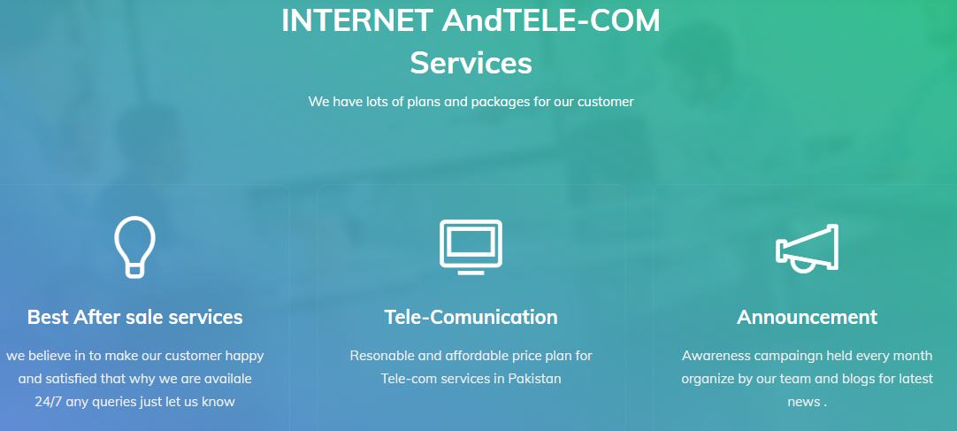

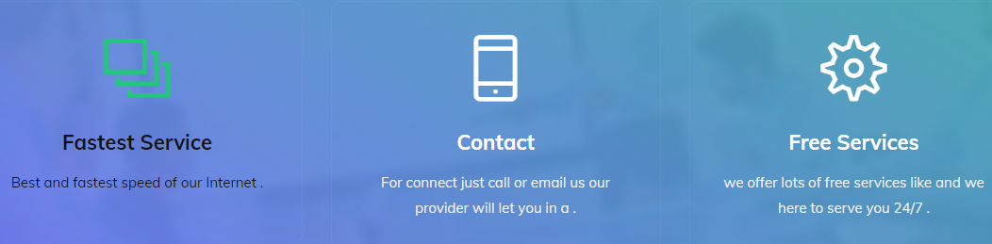

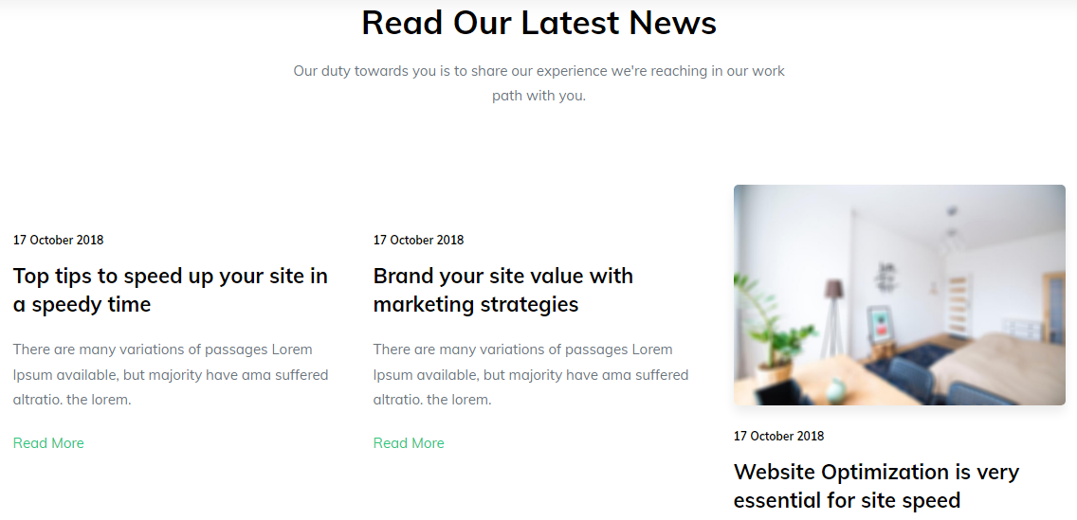

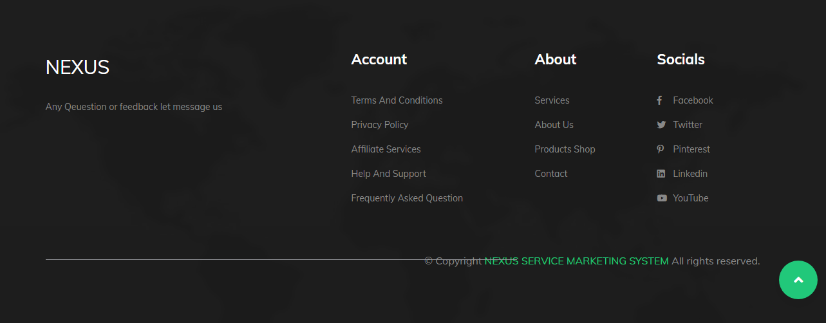

ABOUT US:

1. In about us page, we show our working process.
2. And also some brief intro of Nexus and some news and article.



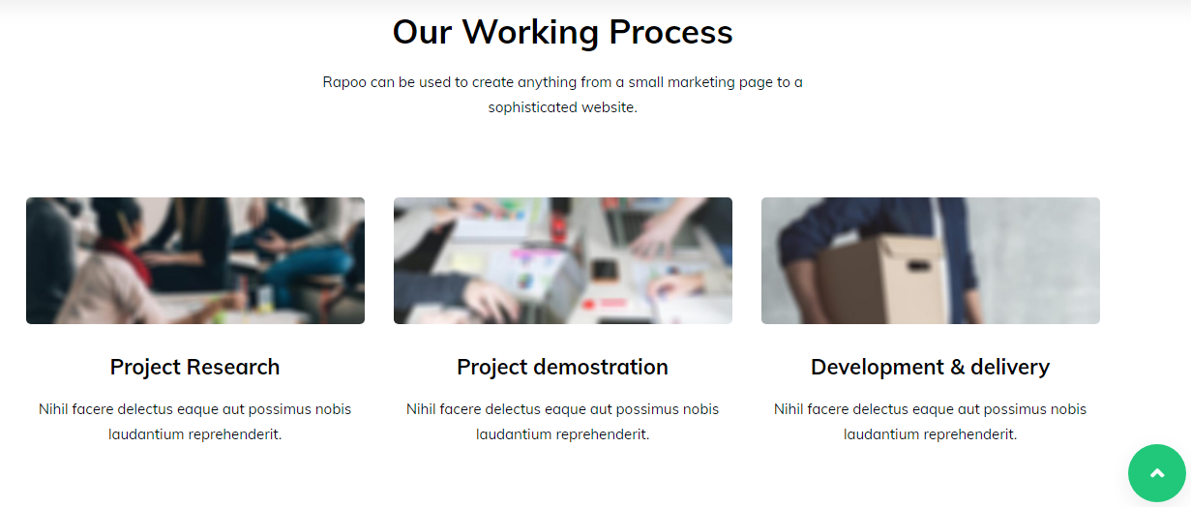

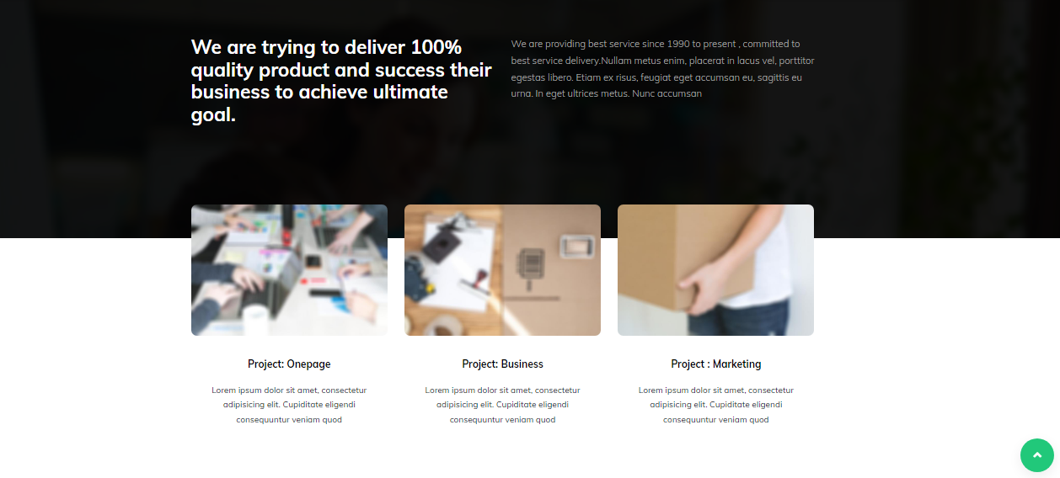

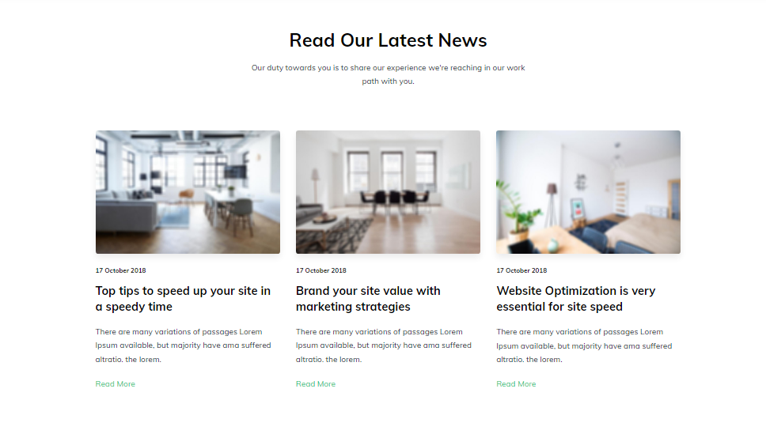

SERVICES:

1. In services page, we describe our services that we offer.
2. And also our working process.



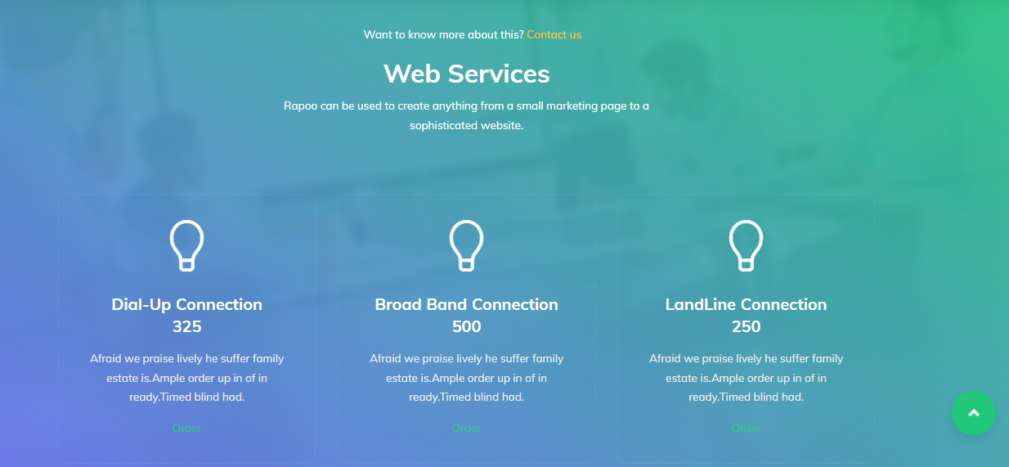

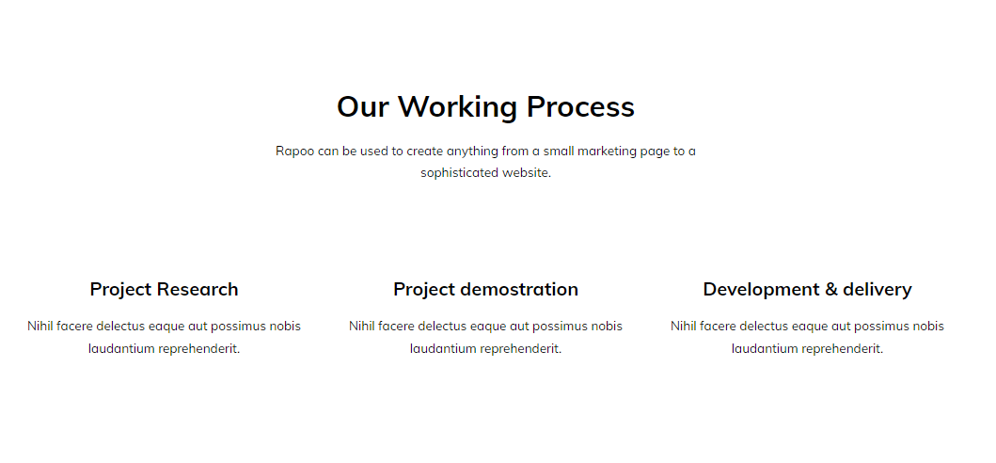

PRODUCTS:

CONTACT:

1. In contact page, we add our address , email and phone number.
2. Down in page, we made a feedback or query form.
3. Left to form we added our location on google map.



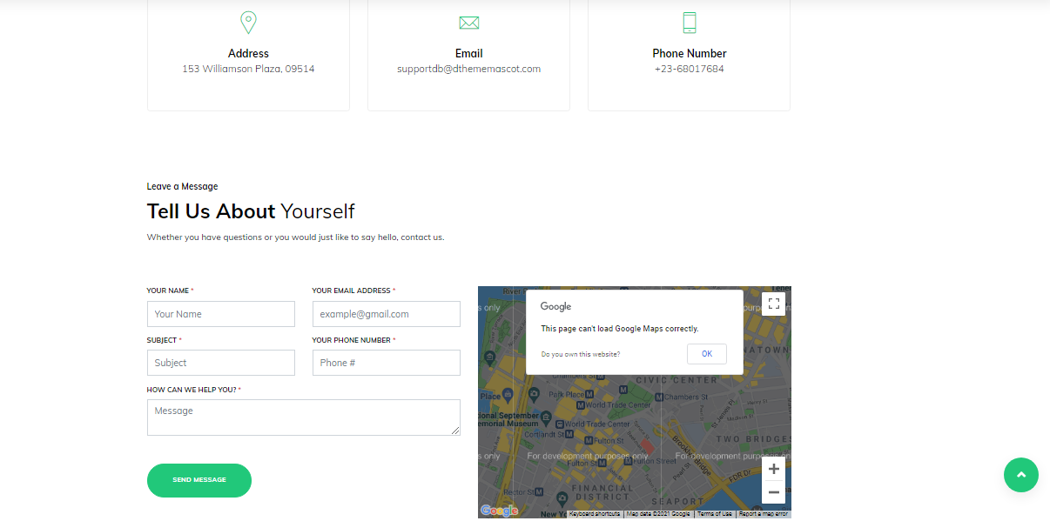

ACCOUNTS:

1. In accounts, we create a dropdown for our user.
2. Dropdown have 2 options these are registered here and login.

